**1.INTRODUCTUON**

**1.1 Overview**

HealthHub Medical Clinic, a healthcare facility, relies on Zoho Books to manage patient billing and invoicing. They can track medical service fees, manage insurance payments, and generate statements for patients. Zoho Books helps them maintain financial transparency and ensures efficient billing processes.

**1.2 Purpose**

1. **Expense** **Tracking:** Medical clinic can use Zoho Books to track and management their expenses, including office rent, utilities and medical supplies.

2**. Invoicing and Billing:** Zoho Books can be used to generate invoices and bills for services rendered by the medical clinic to patients or insurance companies.

3**. Accounting and Bookkeeping:** It helps with general accounting and bookkeeping tasks, such as recording income, expenses and managing financial transactions.

4**. Tax Compliance:** Zoho Books can assist in tax compliance by helping medical clinics organize their financial data for purpose.

5**. Financial Reporting:** The software provides tools for generating financial reports. Which can be useful for analysing the clinic’s financial performance.

**2. PROBLEM DEFINITION & DESIGN THINKING**

**2.1 EMPATHY MAP**

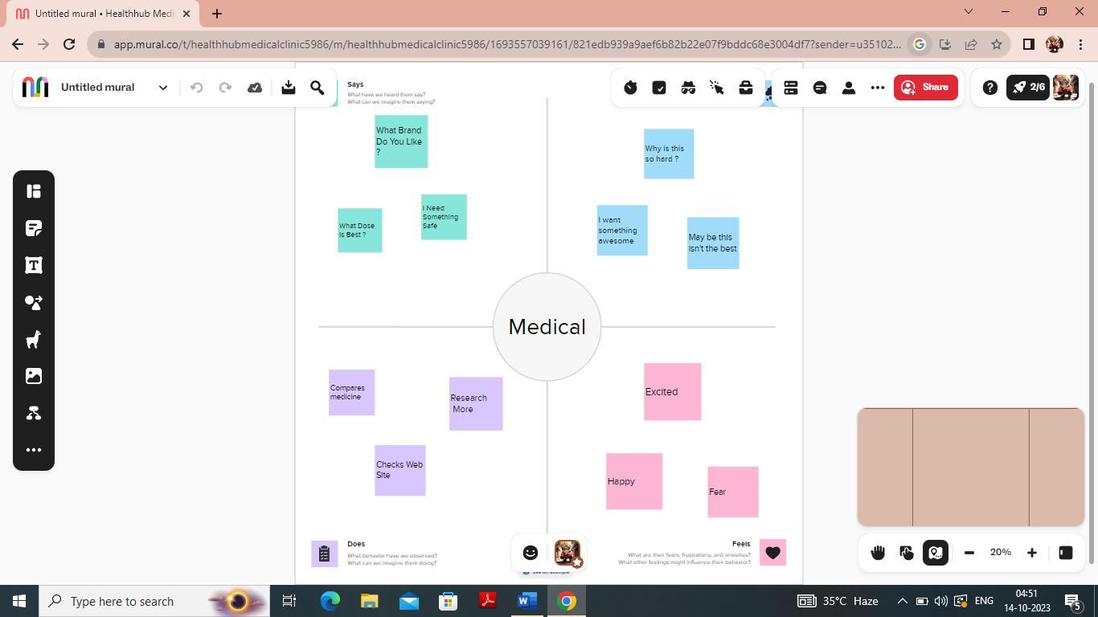

**2.2 BRAINSTROMING**

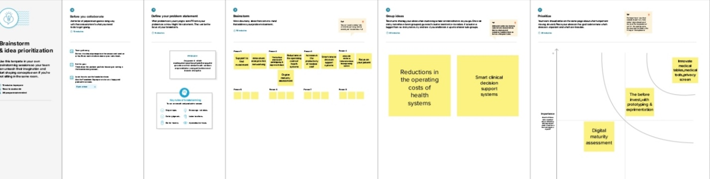

**3.RESULT**

**PROFIT & LOSS A/C**

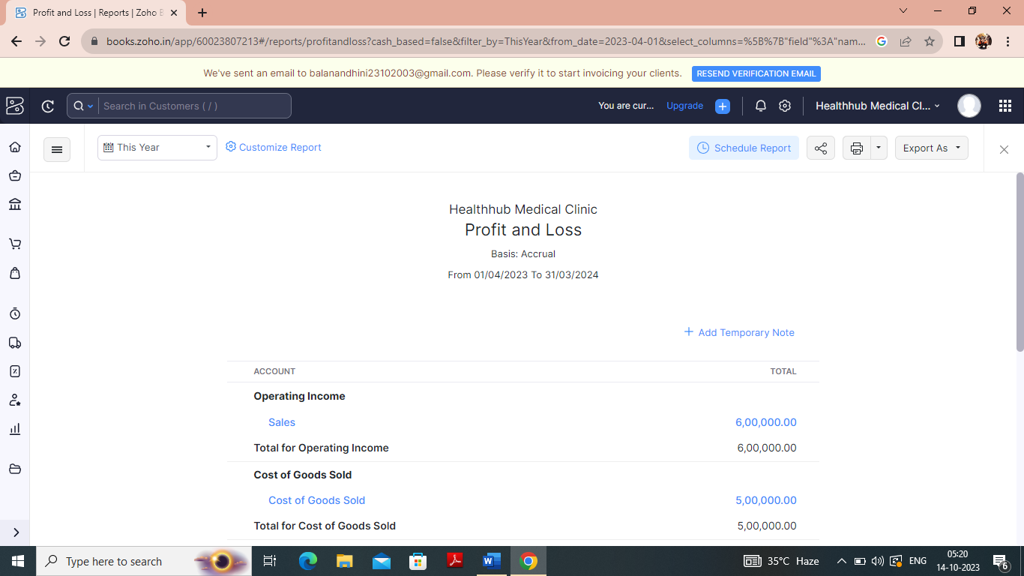

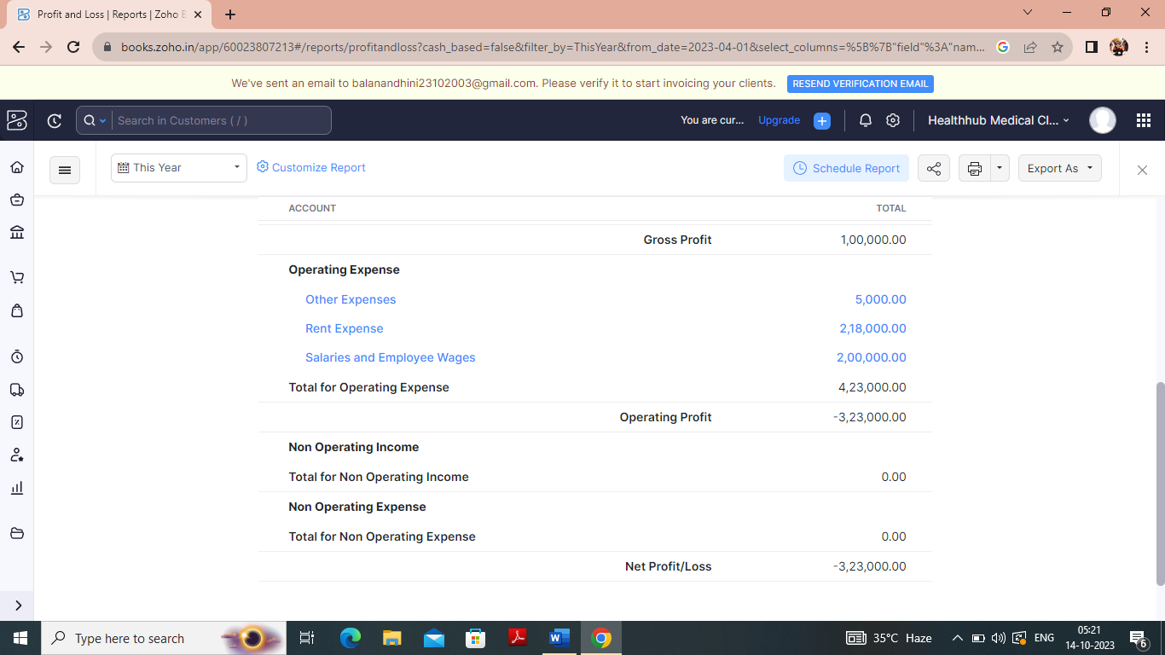

**BALANCE SHEET**

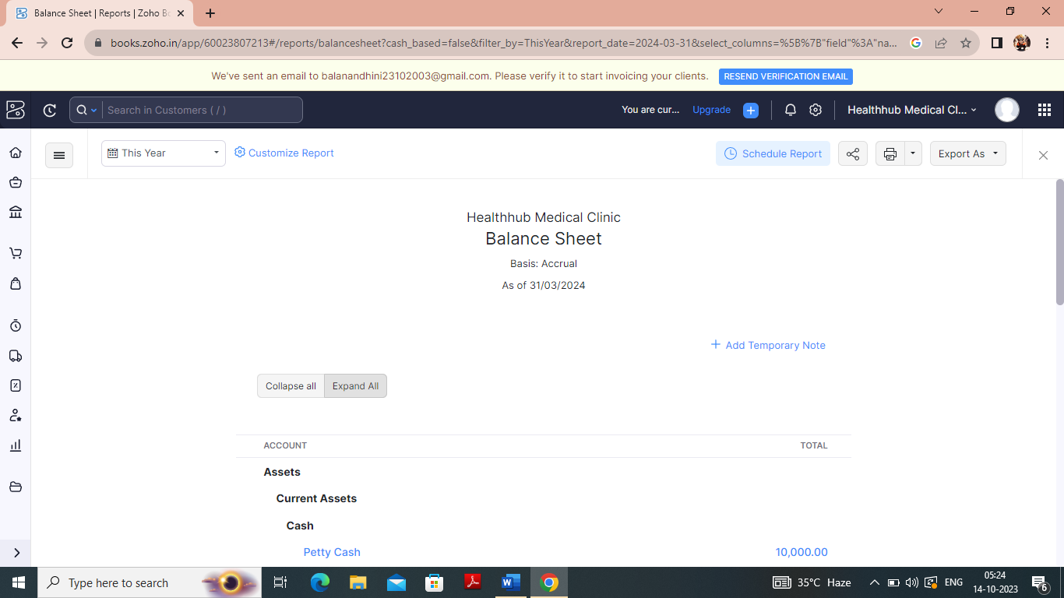

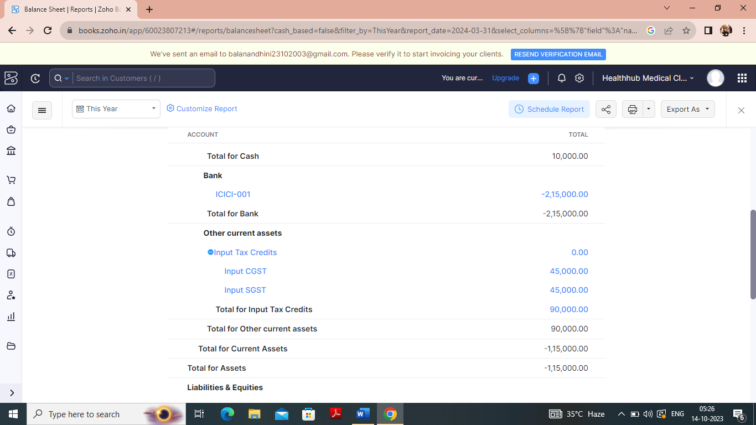

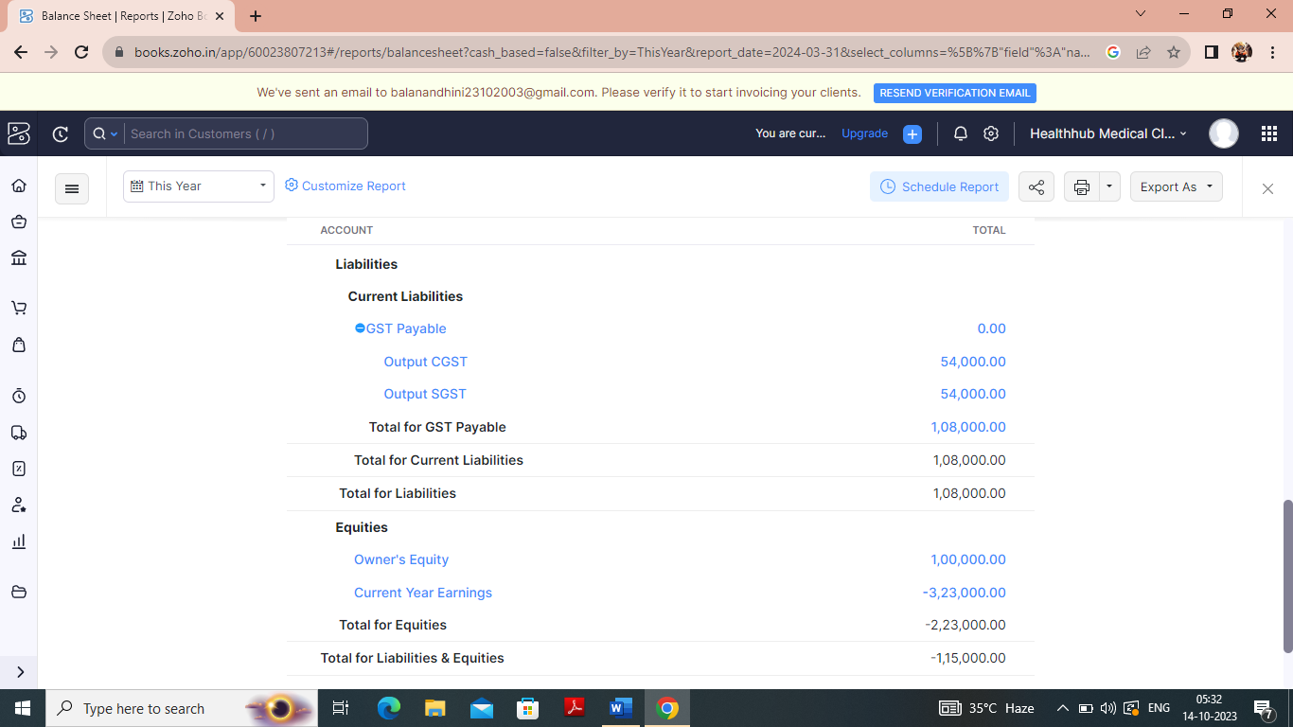

**4. ADVANTAGES & DISADVANTAGES**

**ADVANTAGES**

1. **Financial Management**: Zoho Books can help Healthhub Medical Clinic manage their financial transaction, including revenue from healthcare, expenses and overall financial health.

2**. Automation**: The software can automate various accounting tasks. Such as invoicing expense tracking and bank reconciliation saving time and reducing errors.

3**. Reporting and Analytic**: Zoho Books offers reporting and analytic tools allowing Healthhub Medical Clinic to gain insights into their financial performance and make informed decisions.

4**. Accessibility:** Zoho Books enables access from anywhere making it convenient for Medical Clinic. Especially if they work remotely.

5**. Integration:** Zoho Books can integrate with other Zoho applications and third-party services. Which can be helpful for managing other aspects of the business.

**DISADVANTAGE**

1**. Learning curve:** Implementing and learning to use accounting software can be challenging. Especially for those unfamiliar with accounting principles.

2**. Cost:** Zoho Books like may any software comes with a subscription cost. Which might be an added expense for Healthhub Medical Clinic.

3**. Customization Limitations:** While Zoho Books is customizable. It may not meet all healthcare Clinic specific needs without some development work.

**5. APPLICATION**

1**. Invoicing:** Creating invoices for healthcare packages, accommodations and others health service provide to patient.

2. **Expense Tracking**: Recording expenses related to Medical Clinic, accommodation and other operational costs.

3**. Bank Reconciliation**: Matching transactions from Medical Clinic bank account with entries in Zoho Books to Ensure accruable financial records.

4. **Tax Compliance:** handling various tax requirements that might be applicable to the health industry.

5**. Financial Reporting**: Generating financial report to analyze the company’s performance and make informed decision.

**6. conclusion**

In conclusion, our project to implement Zoho Books has been a significant step towards enhancing our financial management and efficiency. This cloud-based accounting software has enabled us to streamline various financial processes, from invoicing and expense tracking to inventory management and reporting.

Though our use of Zoho Books, we have achieved the following benefits,

Accuracy, Efficiency, Transparency, Scalability.

**7.FUTURE SCOPE**

1. **Automation:** Implement automation for expense tracking and invoicing. This could involve setting up rules to categorize expenses and automatically generate invoice for clints.

2**. Analytics and Reporting**: Enhance report capabilities to gain insights into the financial health of the business. Customized reports for tracking revenue, expenses, and profitability would be valuable.

3**. Multi-Currency Support**: If Healthhub Medical Clinic deals with international clients adding support for multiple currencies and real-time currency conversion could be beneficial.

4. **Expense Approval Workflows**: Implement approval workflows for expenses. Ensuring are validate before they are recorded in Zoho Books.

5**. Mobile App Integration**: Develop a mobile app for Healthhub medical Clinic to capture expenses on the go and sync with zoho Books for real time updates.